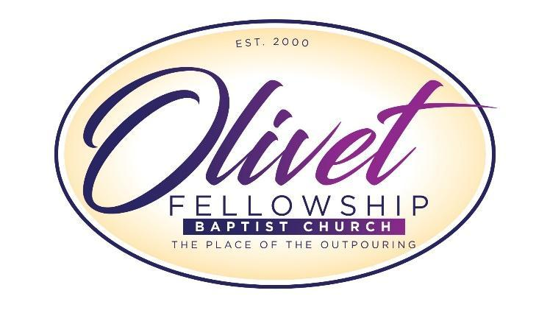

Seeds of Destiny Class of 2024
Scholarship Award

APPLICATION FORM

The Seeds of Destiny Scholarships support graduating high school seniors at Olivet Fellowship Baptist Church. Our ministry provides educational services and financial assistance to deserving students in an effort to help them reach their educational goals. All qualifying high school seniors are encouraged to apply.

Please give careful consideration when completing this application, as your responses are very important when being considered for this award. Make certain that every part of the application is completed, true to the best of your knowledge and your writing is legible. The application, if emailed, can be completed online. If not applicable, use “N/A.” To be considered, your completed application and supporting documents must be received into the church office or into the hands of a designated coordinator no later than Sunday, May 12, 2024 at 12:00 noon.
You will be contacted for an interview date and time with the scholarship committee.

The applicant must be a 2024 graduating high school senior with a minimum cumulative GPA of 2.5 (weighted and unweighted). The applicant must also have been a member of Olivet Fellowship Baptist Church for at least one year and plan to enroll in an accredited college or university in the 2024 fall semester.

Please provide a sealed official transcript. The transcript should come directly from your high school or presented with your scholarship packet in a school-sealed envelope. Also, you will need three letters of recommendation - (from your school, your church, and your community). All recommendations must include a name, an email address and telephone number for confirmation purposes.
DEADLINE – SUNDAY May 12, 2024
12:00 Noon
Submissions will be accepted early online or in the church office.

Seeds of Destiny Scholarship Application
GENERAL INFORMATION

PLEASE TYPE OR PRINT CLEARLY (Blue/Black Ink Only)

Applicant’s Full Name__________________________________________________________

Address/Zip Code_______________________________________________________________

Telephone Number ______________________ Date of Birth______________

Member of Olivet Fellowship Since__________________________________

E-mail Address ________________________________________________________________

Parents/Guardians’ Name_________________________________________________________

Parents/Guardians’ Phone Contact ______________________________________________________

SCHOOL INFORMATION

Name of High School __________________________________________________________

Address and Telephone Number _______________________________________________

Cumulative Grade Point Average _______ _______ (Must be a 2.5 weighted /unweighted)

ACT Test Score _________ SAT Test Score _____________

Name and location of college you plan to attend

________________________________________________________________________

If you have already been accepted, please attach a copy of the acceptance letter.

What are your educational goals and career plans?

____________________________________________________________________________________________________________________________________________________________________________________________________________________________________________________________________________________________________________________________________________________________________________________________________________________________________________________________________________________

Scholarship Essay Topics

Please choose from one of the listed essay topics below. Your essay should be at least 500 words, doubled spaced and formatted in 12 point/Times New Roman font.

Note: Your essay will be judged on format, grammar, punctuation, clarity and how well you dealt with the chosen subject matter.

- Other than your parents and/or grandparents, who has had the most positive impact on your Christian journey? Explain in detail how they helped you to develop your own special and unique relationship with God. Discuss how you are “letting your light shine” and making a difference in your community.

- Recount an incident or time when you experienced failure. How did it affect you, and what lessons did you learn?

- Reflect on a time when you challenged a belief or idea. What prompted you to act? Would you make the same decision again?

- Discuss an accomplishment or event, formal or informal, which marked your transition
from childhood to adulthood. Explain how you grew personally from that experience.

- What do you consider to be the single most important societal problem? Why? How will
you be the change the world needs to see?

- How has your family background affected the way you see the world? And, how will your area of study and profession impact your future and influence those around you?

In the spaces provided, list, discuss or describe:
(If more space is needed, please attach additional sheets)

CHURCH ACTIVITIES

SCHOOL ACTIVITIES

COMMUNITY INVOLVEMENT

HONORS, SCHOLARSHIPS, AND AWARDS

I certify that all of the information provided on this application is true and this I have not willingly withheld any pertinent information. I will use scholarship funds for educational purposes only.

_____________________________________________________________________________________

Signature Date

Letters of Recommendation

- From a High School Representative:

- Yes included
- No - not included, please state reason below

________________________________________

- From a Church Representative:

- Yes included
- No - not included, please state reason below

________________________________________

- From a Community Representative:

- Yes included
- No - not included, please state reason below

________________________________________

CHECK LIST

- Graduating High School Senior for 2024 School Year
- Overall Cumulative GPA of 2.5 (weighted and unweighted)
- Application is completely filled out (Typed or neatly printed)
- Three (3) letters of recommendation (one from a church leader, one from a teacher, counselor or administrator, and one showing community service involvement)
- Official transcript is included and is in a school sealed envelope
- Application has been signed and dated
- College acceptance letter included ____Yes ____No
- Essay enclosed
- Professional headshot photo with Profile Sheet (absolutely no selfies)

Applicant’s Name __________________________ Date ___________ All applicants will be contacted for an interview with the scholarship committee

High School Graduate Profile Sheet (please print)

Name______________________________________________

Address_____________________________________________

Parents/Guardian______________________________________

Student and Parent Telephone Number____________________
___________________________________________________

Email Address _______________________________________

Name of College or University Attending__________________
___________________________________________________

Type of Degree Seeking _____________________________

High School Activities, Honors, Awards:
____________________________________________________
____________________________________________________
____________________________________________________

Deadline Sunday May 12, 2024 12:00 Noon - Profile Sheet must be turned in with a professional headshot photo (no selfies)

